# Chapter 3: Binding the SAPUI5 application to the OData service

In this chapter, we shall see how we bind the SAPUI5 “personslist” application to the developed OData service, so that the data is persistent now.

This involves the following steps

1. **Add the Destination to SAP Cloud Platform**
2. **Modify the existing SAPUI5 application to consume the OData service**
   1. **Modify the neo-app.json file**
   2. **Modify the manifest.json file**
   3. **Modify the view and controller file**
3. **Deploy the application to SAP Cloud Platform**
4. **Add the Destination to SAP Cloud Platform**

In the first step,configure connectivity from the HCP cloud application to the OData backend system(which you have created in chapter:2), so that data can be retrieved from the backend. SAP HANA Cloud Platform account allows secured connections from your account to external backend systems which are enabled by configuring dedicated *Destination files*.

1. Click on the *Destinations* tabin your HANA Cloud Platform cockpit.
2. From the empty Destinations table click *Import Destination …*

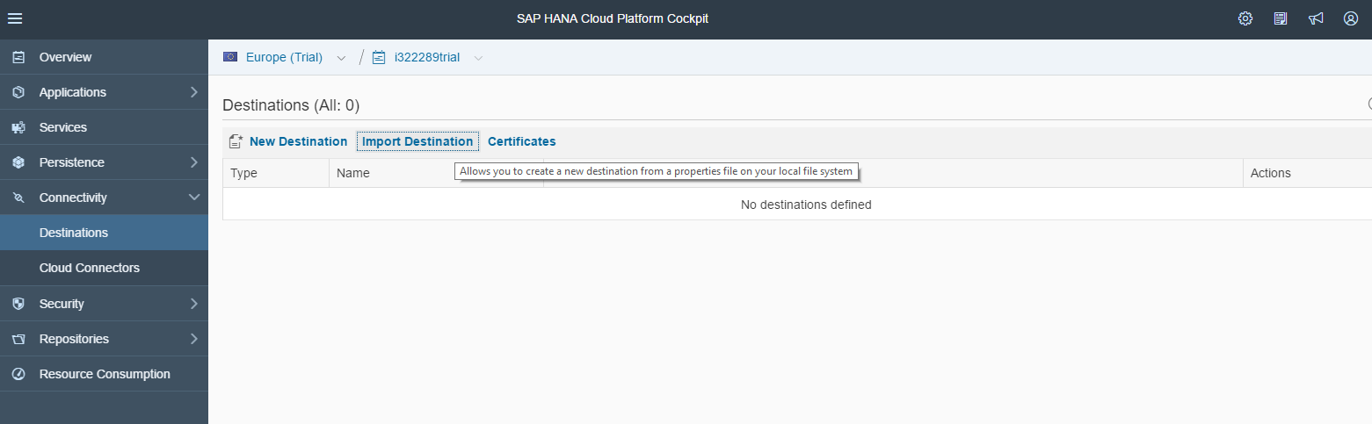

1. Import the “Personslist.txt” destination file [Attached below in this file and remove .txt extension] to your local file system.



1. Replace the <accountname> in the URL with your account name (ending with trial) as below and click on save button.

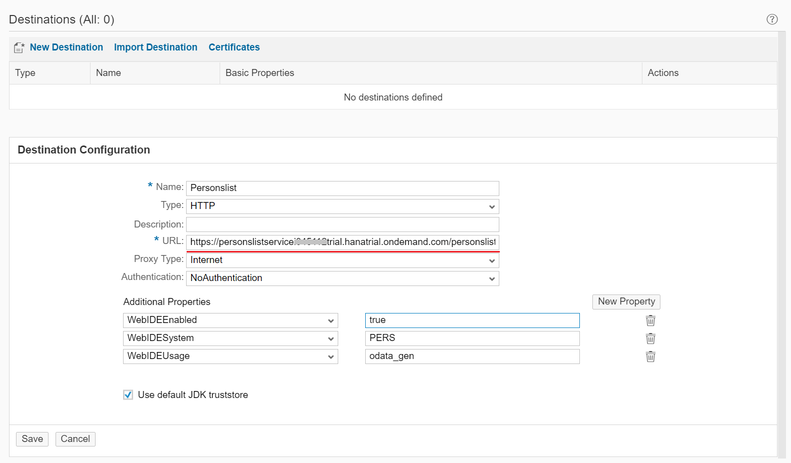

**Modify the existing SAPUI5 application to consume the OData service**

**Step 1: Modify the neo-app.json file:**

*Add the following code to the neo-app.json file* ***(delete the initial code)*** *this will result in the following code in the* **neo-app.json** *file as shown in the snapshot.*



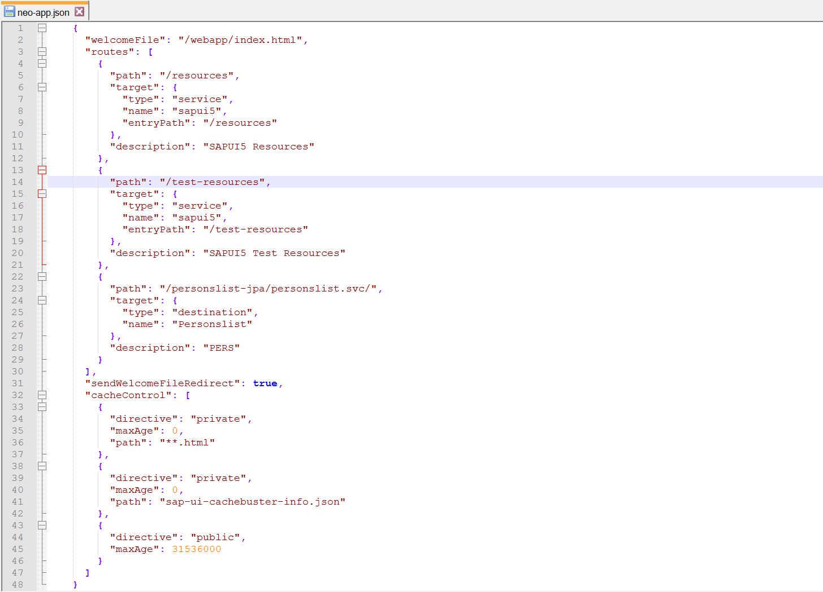

**Step 2: Modify the manifest.json file:**

*Add the following code to the manifest.json file* ***(delete the initial code)*** *this will result in the following code in the* **manifest.json** *file as shown in the snapshot.*



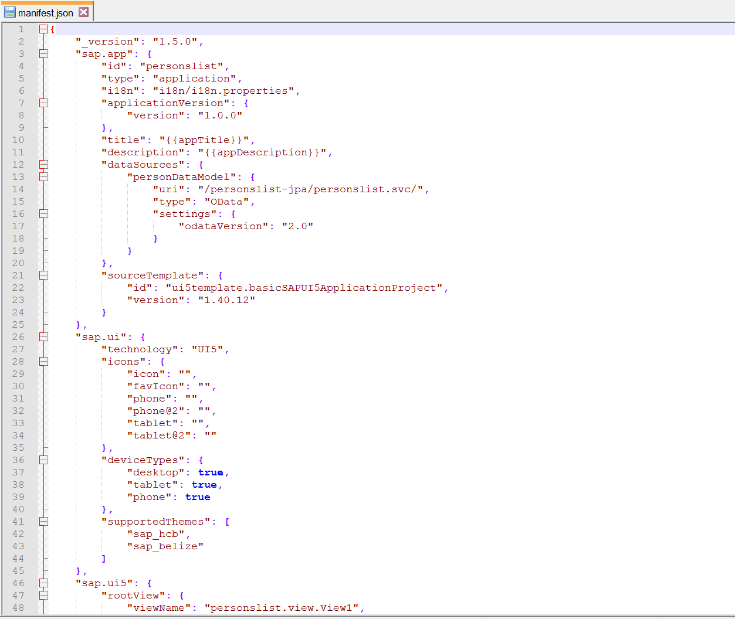

**Step 3: Modify the view and controller file:**

*Add the following code to the view and controller file* ***(delete the initial code)*** *this will result in the following code in the* **view and controller file** *as shown in the snapshot.*

 

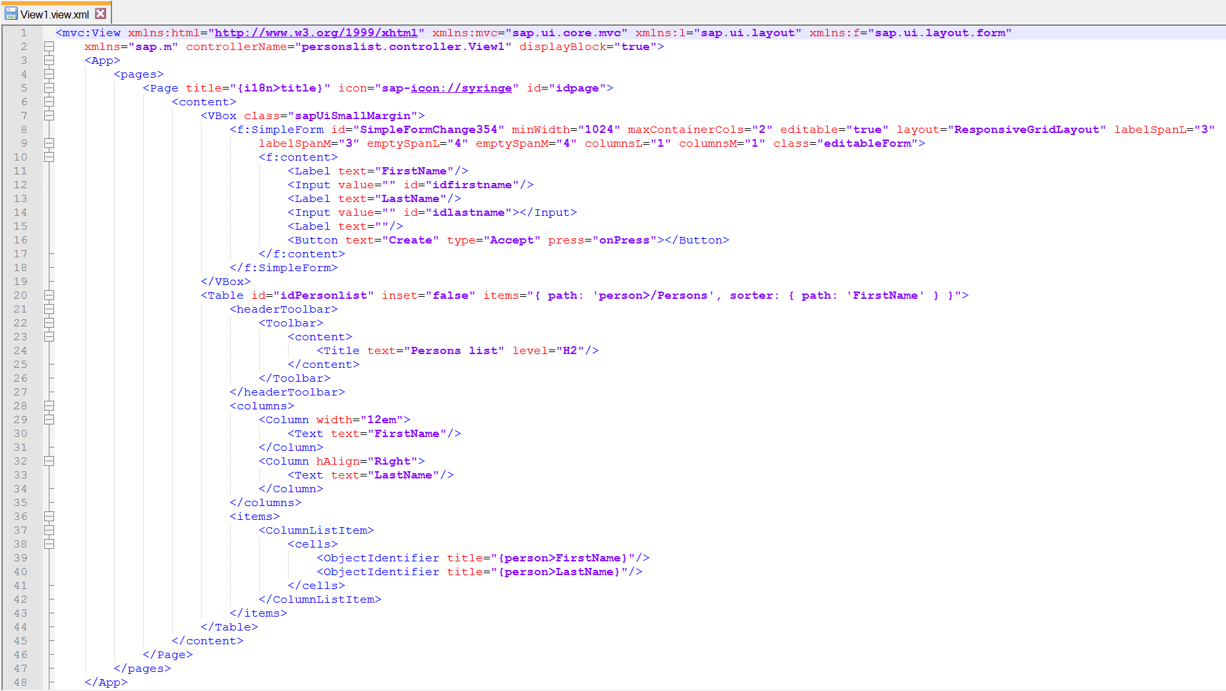

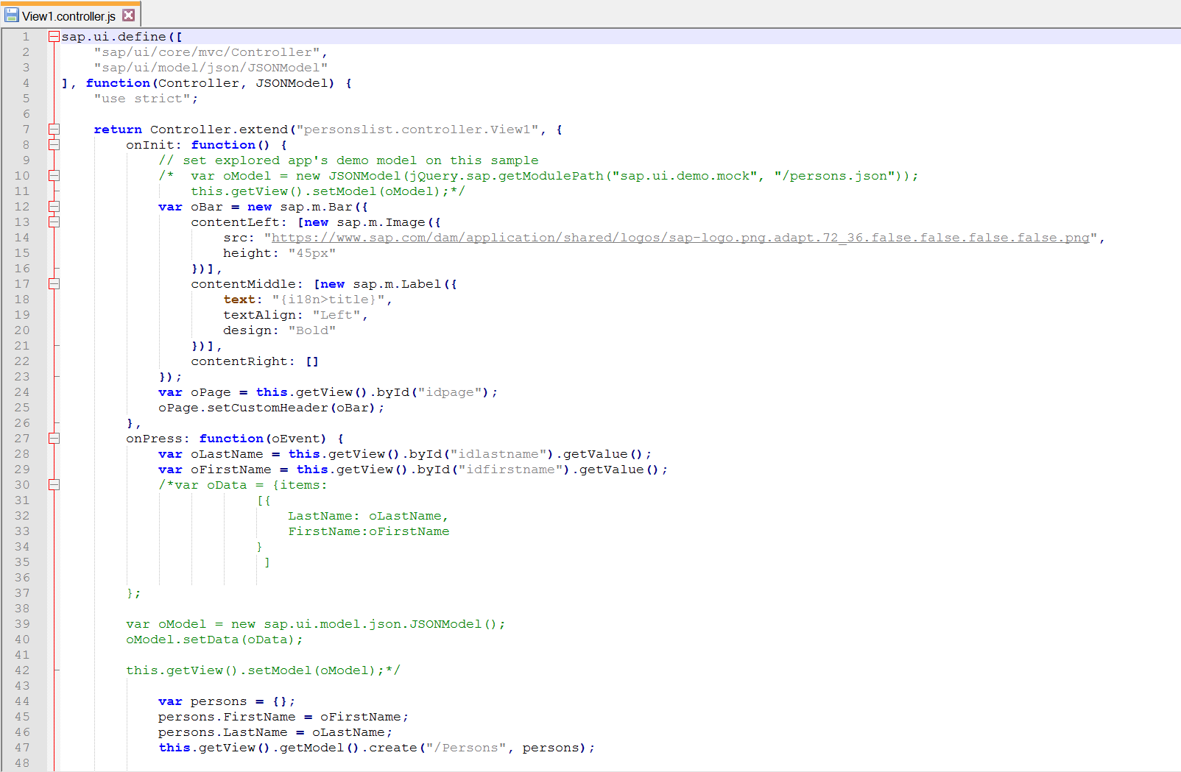

**Deploy the application to SAP Cloud Platform**

*In the workspace, right-click the project and choose* Start of the navigation path **Deploy** Next navigation step **Deploy to SAP Cloud Platform** End of the navigation path

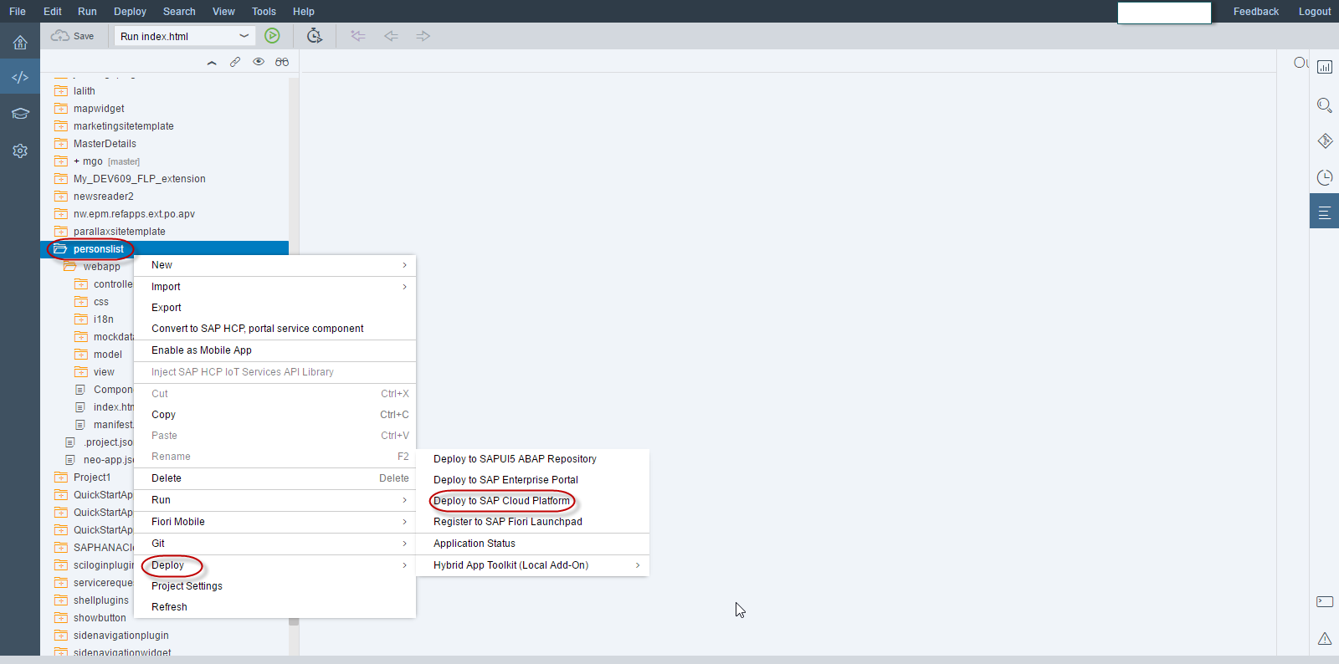

*Enter the application name and click on deploy to deploy the application on SAP cloud platform*

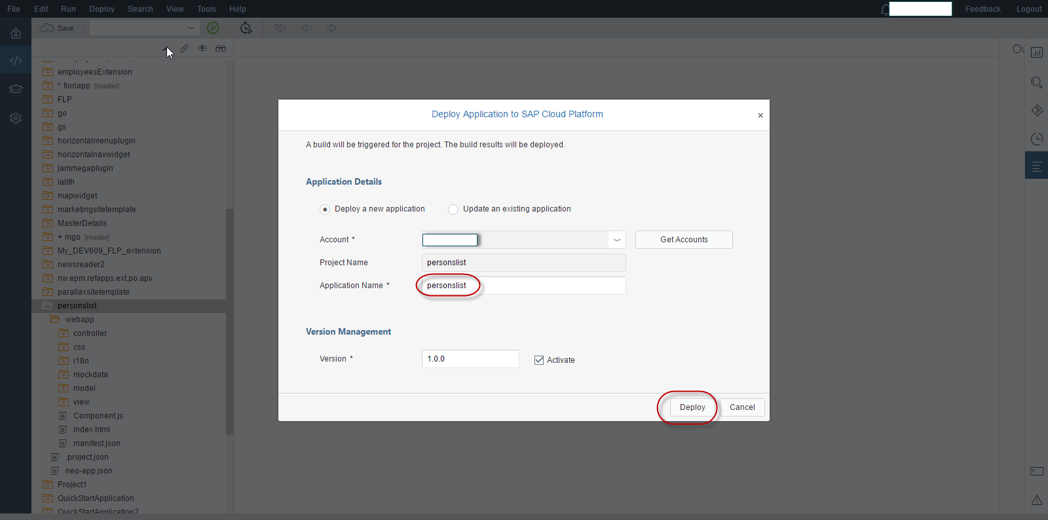

*Click on the link “Open the active version of the application” to open the application.*

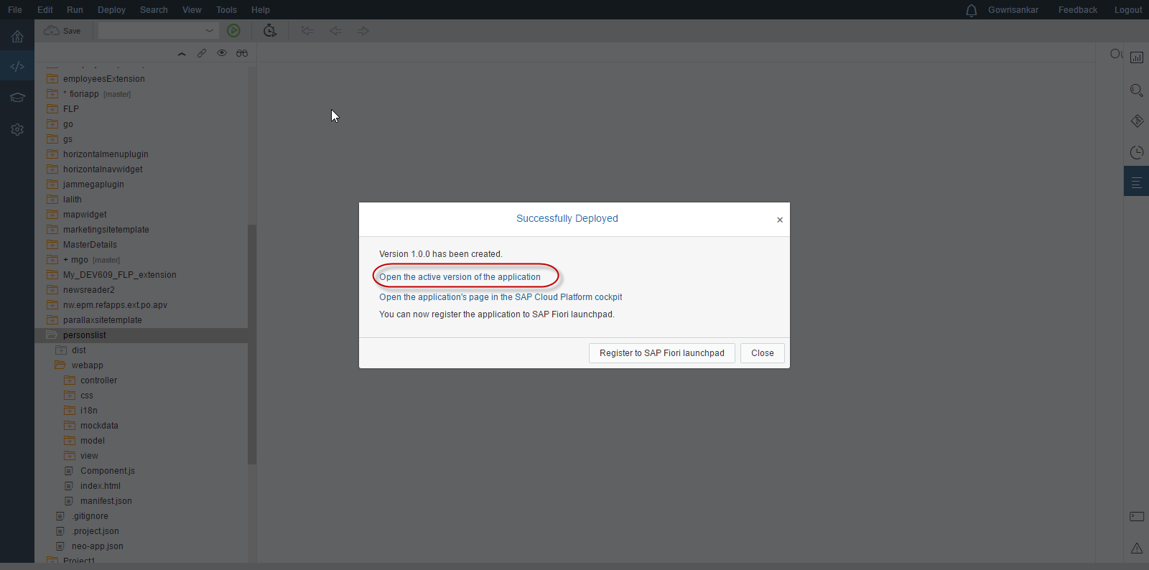

Please check your SAPUI5 application that allows the User to enter his first name and last name and click on a “Add” button that inserts the entered input to the table shown.

Refresh your app and check your entry remain in the table just to ensure that it reads the data from database.

